1. Transfer function between the input voltage and the speed of the motor shaft,

$G\left(s\right)=\frac{ω\left(s\right)}{v_{a}\left(s\right)}=\frac{0.002}{0.01s+0.00104}$.

1. Step Response:

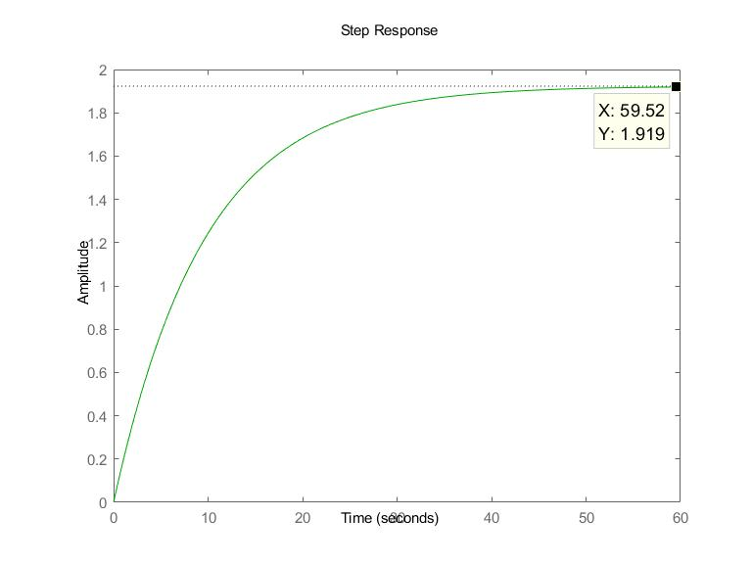

**Fig 1**

Steady State = 1.919

Time constant = $\frac{0.01}{0.00104}=9.615$*s*

1. Step response information of G(s)

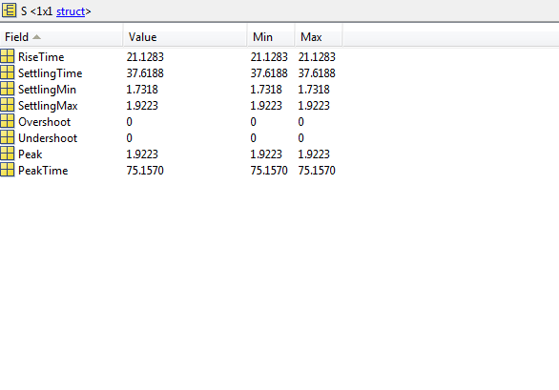

**Fig 2**

Rise time = 21.1283 *s*

Settling time = 37.6188 *s*

1. Steady State value can be obtained as time t → ∞, which in Laplace domain would mean s → ∞. Thus, $\frac{w\left(s\right)}{v_{a}\left(s\right)}=\frac{0.002}{0.00104}=1.923$. Steady State value found in Matlab = 1.919. This difference is because the Steady State value in Matlab is approximate and is taken at time t = 59.52 *s*, whereas the theoretical value is considered to be Steady State value as t → ∞.
2. Transfer function between the shaft's angel and input voltage,

$H\left(s\right)=\frac{ϴ\left(s\right)}{v_{a}\left(s\right)}=\frac{0.002}{s(0.01s+0.00104)}$. This is a second order system.

1. Block diagram of unity feedback loop to the system: ω/va

 va

ω

**Fig 3**

Closed loop transfer function, $\frac{ω\left(s\right)}{v_{a}\left(s\right)}=\frac{0.002}{0.01s+0.00304}$

1. Step response of the unity feedback closed loop system KG(s)

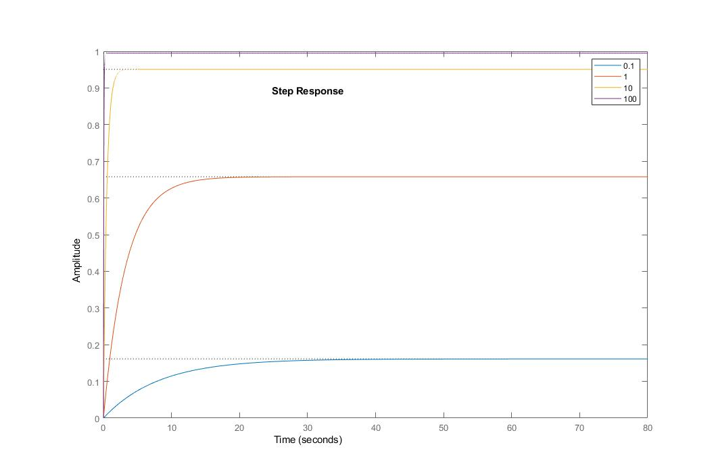

**Fig 4**

Step response information of KG(s)

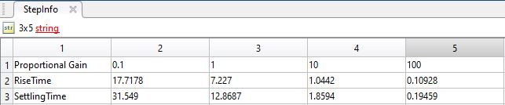

**Fig 5**

**Fig 4** and **Fig 5** shows the effect of proportional controller on the system. As the proportional gain increases, the rise time decreases and settling time decreases. As this is a first order system, there was no overshoot.

1. Step response of the unity feedback closed loop system KH(s)

Fig 6

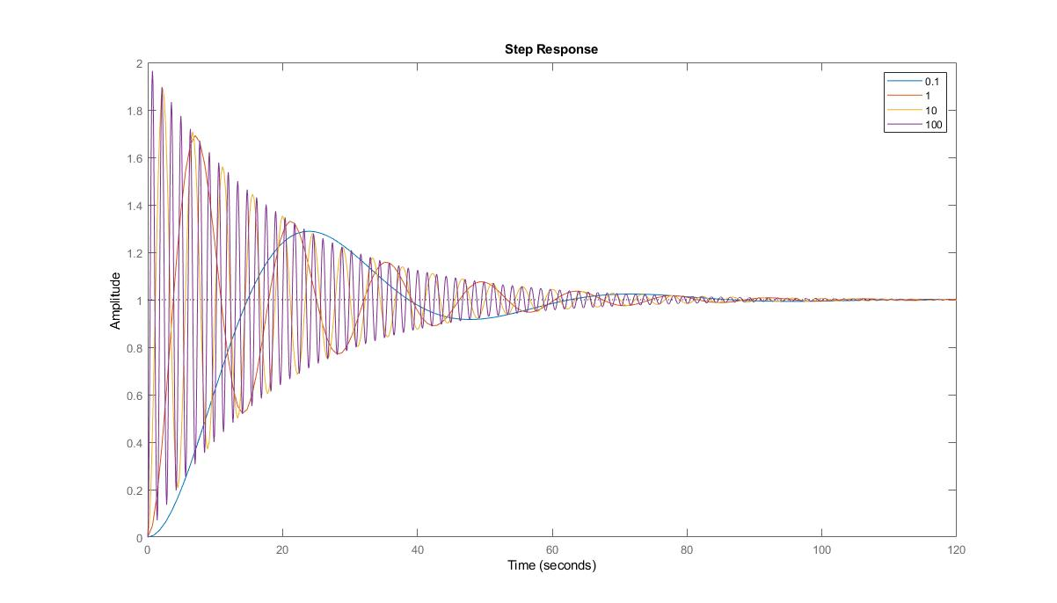

**Fig 6**

Step response information of KH(s)

**Fig 7**

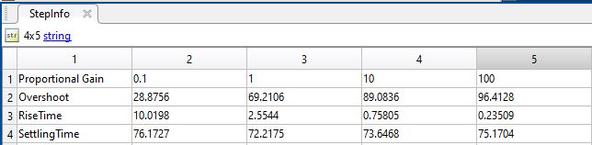

**Fig 6** and **Fig 7** shows the effect of proportional controller on the system. Increase in the proportional gain increases the overshoot, reduces the rise time and reduces the settling time.

1. For overshoot of 20%, to find the maximum value of K, we need to go through a few steps.

Step 1: Find the value of the damping ratio for 20% overshoot

$e^{\frac{−πζ}{\sqrt{1−ζ^{2}}}}=0.2$, ζ = $\sqrt{\frac{{(ln⁡⁡(0.2))}^{2}}{π^{2}+{(ln⁡⁡(0.2))}^{2}}}=0.2079$

Step 2: Find the closed loop transfer function with proportional controller K, KH(s)

$$\frac{0.2K}{s^{2}+0.104s+0.2K}$$

Step 3: Apply Routh-Hurwitz stability criterion

|  |  |  |
| --- | --- | --- |
| s2 | 1 | 0.2K |
| s1 | 0.104 | 0 |
| s0 | b1 |  |

b1 =

K > 0 for all times for the system to be stable, for which there will be no change in sign in the first column.

Step 4: Equate and solve with the following equation

$$\frac{A}{s^{2}+2ζω_{n}s+{ω_{n}}^{2}}$$

Natural frequency, ωn = 0.104/(2*0.2079) = 0.25 *s-1*

K = 0.252/0.2 = 0.3125

Thus, maximum value of K = 0.3125

1. For rise time of 4 seconds, to find the value of K, we need to go through a few steps

Step 1: Find the natural frequency

$ω_{n}=\frac{π}{t_{r}}$ = 0.7854 *s-1*

Step 2: Find the closed loop transfer function with proportional controller K, KH(s)

$$\frac{0.2K}{s^{2}+0.104s+0.2K}$$

Step 3: Equate and solve with the following equation

$$\frac{A}{s^{2}+2ζω_{n}s+{ω_{n}}^{2}}$$

K = 0.7854/0.2 = 3.927

1. Bode plot of transfer function H

**Fig 8: Gain Margin**

**Fig 9: Phase Margin**

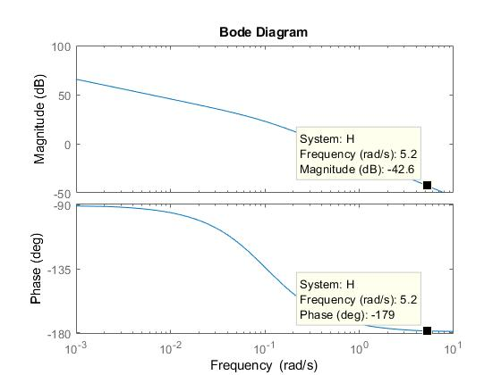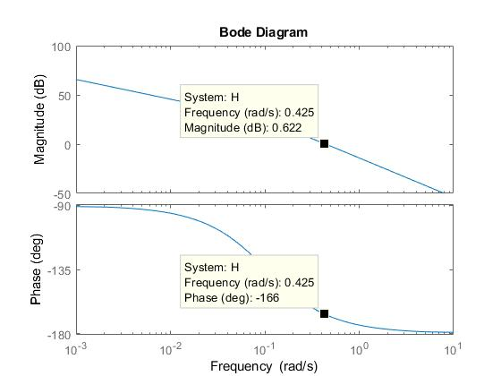

Gain Margin = 42.6 dB, at ω = 5.2 *s-1*

Phase Margin = -166+180 = 140, at ω = 0.425 *s-1*

Definitions

Gain Margin - The gain margin is the amount of gain increase or decrease required to make the loop gain unity at the frequency, where the phase angle is –180°

Phase Margin - The phase margin is the difference between the phase of the response and –180° when the loop gain is 1.0

1. Root locus of the transfer function H

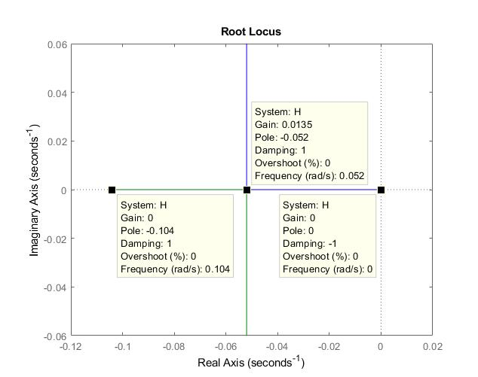

**Fig 10**

Root locus diagram is a graphical method for examining how the roots of a system change with variation of a certain system parameter.

From the **Fig 10**, we can observe that the system becomes unstable at a Gain of 0.0135.

1. Root locus of the transfer function H, with controller block

**Fig 11**

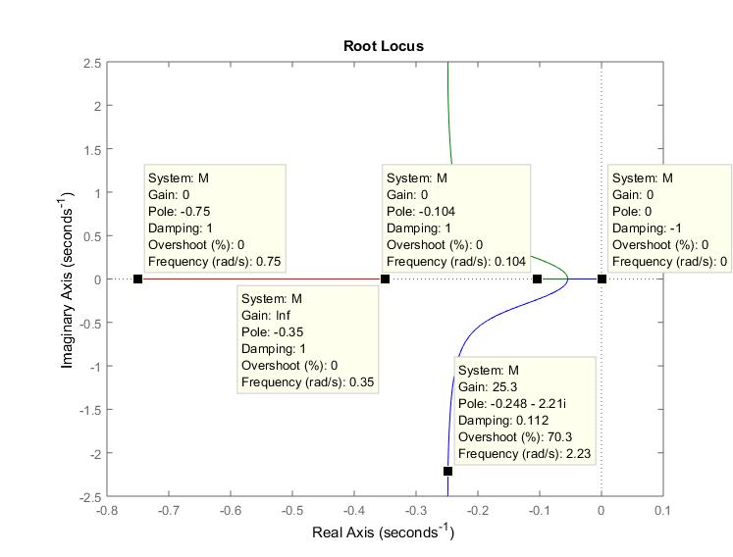

From the **Fig 11**, we can observe that the system is stable for all values of K because all the poles are on the left hand side plane.

Appendix

-Units are formatted as italic

Source code:

s = tf('s');

% Q2 to Q4

G = 0.002/(0.01*s+0.00104);

figure(1)

stepplot(G);

S = stepinfo(G);

% Q5, Q11

H = 0.002/(s*(0.01*s+0.00104));

figure(2);

stepplot(H);

T = stepinfo(H);

% Q7

StepInfoG = ["Proportional Gain",0,0,0,0;

"RiseTime",0,0,0,0;

"SettlingTime",0,0,0,0]

figure(3);

hold on;

K = [0.1 1 10 100];

for i = 1:4

J = 0.002*K(i)/(0.002*K(i)+0.01*s+0.00104);

stepplot(J);

S = stepinfo(J);

StepInfoG(1,i+1) = K(i);

StepInfoG(2,i+1) = S.RiseTime;

StepInfoG(3,i+1) = S.SettlingTime;

legendInfo{i} = [num2str(K(i))];

end

legend(legendInfo);

hold off;

% Q8

StepInfoH = ["Proportional Gain",0,0,0,0;

"Overshoot",0,0,0,0;

"RiseTime",0,0,0,0;

"SettlingTime",0,0,0,0]

figure(4);

hold on;

K = [0.1 1 10 100];

for i = 1:4

L = 0.002*K(i)/(0.002*K(i)+s*(0.01*s+0.00104));

stepplot(L);

S = stepinfo(L);

StepInfoH(1,i+1) = K(i);

StepInfoH(2,i+1) = S.Overshoot;

StepInfoH(3,i+1) = S.RiseTime;

StepInfoH(4,i+1) = S.SettlingTime;

legendInfo{i} = [num2str(K(i))];

end

legend(legendInfo);

hold off;

% Q11

figure(5);

bode(H);

% Q12

figure(6);

rlocus(H);

% Q13

figure(7);

Ks = (s+0.35)/(s+0.75);

M = Ks*H;

rlocus(M);